Appendix A: Systematic Literature Review

PICO Criteria
Table A1: PICO eligibility criteria
PICOS item | Inclusion criteria | Exclusion criteria
Population | - Adult and pediatric patients with familial chylomicronemia syndrome (FCS) | - Secondary cause of hypertriglyceridemia (diabetes, hypothyroidism, obesity, alcohol consumption)  - Animal studies, non-human studies (e.g., tissue, assay)
Intervention | - Olezarsen or plozasiran or volanesorsen | N/A
Comparator | - Any, placebo, or no treatment (i.e., no restrictions) | N/A
Outcomes | Any Efficacy/Effectiveness outcomes including but not limited to:  - Percentage change from baseline in fasting TG levels  - Percentage change from baseline in fasting apo B-48 (apoB-48) and apoC-III  - Percentage change from baseline in fasting HDL-C and non-HDL-C  - Adjudicated acute pancreatitis event rate  - Percentage of participants who achieve ≥ 40% or ≥ 70% reduction in fasting TG  - Percentage of participants who achieve fasting TG ≤ 880 or ≤ 500 mg/dL  Any Safety outcomes including but not limited to:  - Adverse events (AEs)  - Serious adverse events (SAEs)  - Treatment-related AEs or SAEs  - Withdrawal rates  - Number of withdrawals due to any reason  - Mortality  - Treatment-related mortality | N/A
Study design | Clinical trials  - Randomized clinical trials  - Non-randomized trials  - Single arm trials  - Pragmatic trials  Observational Studies  - Retrospective cohort studies  - Prospective cohort studies  - Cross-sectional studies  - Case-control studies  Included for library:  - Systematic reviews, meta-analysis, ITC, MAIC* | - Review articles (e.g., narrative reviews)  - Books, letters, notes, comments  - Case reports/series  - Pre-clinical studies
Additional criteria (limits)
Timing | None
Setting | None
Language | English
Publication date limit | None
AE: adverse event; apoB: apolipoprotein B; apoC: apolipoprotein C; HDL-C: high-density lipoprotein cholesterol; ITC: indirect treatment comparison; MAIC: matching adjusted indirect treatment comparison; N/A: not applicable; SAE: serious adverse event
*Bibliographies of previously published SLR, meta-analysis, ITC, MAIC will be searched to identify relevant evidence.

Search Strategies for Main Electronic Databases
Table A2: Search strategy for Embase® via OvidSP
Database: Embase 1974 to 2024 August 01
Search executed: August 02, 2024
# | String | Hits
1 | exp lipoprotein lipase deficiency/ | 1316
2 | exp hyperlipoproteinemia type 1/ | 1316
3 | Familial chylomicronemia.mp. | 432
4 | Familial hyperchylomicronemia.mp. | 61
5 | familial Hypertriglyceridemia.mp. | 226
6 | lipoprotein lipase deficiency.mp. | 485
7 | (hyperlipoproteinemia type 1 or hyperlipoproteinemia type I).mp. | 1333
8 | or/1-7 | 1831
9 | (exp animal/ or nonhuman/) not exp human/ | 7395417
10 | (Ephemera or "Introductory Journal Article" or News or "Newspaper Article" or Editorial or Comment or Overall or Letter or Short Survey or Tombstone or Books).pt. or in vitro study/ or (commentary or editorial or comment or letter or mice or rat or mouse or animal or murine).ti. | 5498569
11 | case reports.pt. or case report$.jw. or (case report or case study or case series or woman or man or child or adolescent or female or male or boy or girl or infant or unusual case).ti. | 1291201
12 | or/9-11 | 12238673
13 | (conference or conference abstract or conference review).pt. | 5990318
14 | limit 13 to yr="2022 -Current" | 749907
15 | 13 not 14 | 5240411
16 | 12 or 15 | 16569849
17 | 8 not 16 | 1196

Table A3: Search strategy for MEDLINE® via OvidSP
Database: MEDLINE ALL 1946 to August 01, 2024
Search executed: August 02, 2024
# | String | Hits
1 | exp lipoprotein lipase deficiency/ | 669
2 | Familial chylomicronemia.mp. | 243
3 | Familial hyperchylomicronemia.mp. | 132
4 | familial Hypertriglyceridemia.mp. | 147
5 | lipoprotein lipase deficiency.mp. | 334
6 | (hyperlipoproteinemia type 1 or hyperlipoproteinemia type I).mp. | 683
7 | or/1-6 | 1088
8 | (exp animal/ or nonhuman/) not exp human/ | 5244920
9 | (Ephemera or "Introductory Journal Article" or News or "Newspaper Article" or Editorial or Comment or Overall or Letter or Short Survey or Tombstone or Books).pt. or in vitro study/ or (commentary or editorial or comment or letter or mice or rat or mouse or animal or murine).ti. | 3857162
10 | case reports.pt. or case report$.jw. or (case report or case study or case series or woman or man or child or adolescent or female or male or boy or girl or infant or unusual case).ti. | 3064349
11 | or/8-10 | 10712801
12 | 7 not 11 | 707

Table A4: Search strategy for Cochrane Central Register of Controlled Trials via OvidSP
Database: CENTRAL June 2024
Search executed: August 02, 2024
# | String | Hits
1 | exp lipoprotein lipase deficiency/ | 29
2 | Familial chylomicronemia.mp. | 57
3 | familial Hypertriglyceridemia.mp. | 4
4 | lipoprotein lipase deficiency.mp. | 6
5 | (hyperlipoproteinemia type 1 or hyperlipoproteinemia type I).mp. | 63
6 | or/1-5 | 84
7 | (exp animal/ or nonhuman/) not exp human/ | 3665
8 | (Ephemera or "Introductory Journal Article" or News or "Newspaper Article" or Editorial or Comment or Overall or Letter or Short Survey or Tombstone or Books).pt. or in vitro study/ or (commentary or editorial or comment or letter or mice or rat or mouse or animal or murine).ti. | 24202
9 | case reports.pt. or case report$.jw. or (case report or case study or case series or woman or man or child or adolescent or female or male or boy or girl or infant or unusual case).ti. | 39148
10 | or/7-9 | 66526
11 | 6 not 10 | 83

Search Strategies for Gray Literature
Table A5: Search strategy for US clinical trial registry (https://clinicaltrials.gov/)
Database: ClinicalTrials.gov
Date of search: August 19, 2024
# | Search String | Hits
1 | Condition or Disease: Familial Chylomicronemia Syndrome  Study Results: Completed  Phase: All | 9

Table A6: Search strategy for EU clinical trial registry (https://www.clinicaltrialsregister.eu/)
Database: ClinicalTrialsRegister.eu
Date of search: August 19, 2024
# | Search String | Hits
1 | Search Terms: Familial Chylomicronemia Syndrome  Results Status: Completed | 6

PRISMA Flow Diagram
Figure A1: PRISMA flow diagram
Records identified from:
Embase (k = 1,196)
MEDLINE® (k = 707)
CENTRAL (k = 83)
Records removed before screening:
Duplicate records removed (k = 463)
Records screened
(k = 1,523)
Records excluded
(k = 1,501)
Records sought for retrieval
(k = 22)
Records excluded:
Outcomes (k = 1)
Study design (k = 6)
Duplicate (k = 1)
Other* (k = 7)
Records identified from:
Hand searching (k = 1)
Publications included in review
(k = 8) pertaining to 7 unique studies
Screening
Records sought for retrieval
(k = 1)
Identification of studies via databases and registers
Identification of studies via other methods
Identification
Included

Records assessed for eligibility (k = 1)
Records assessed for eligibility (k = 22)

*No additional outcomes than primary publication; k: number of studies

Appendix B: Matching-Adjusted Indirect Comparison

Distributions of patient weights
Figure B1: Histograms of patient weights for the risk of at least one AP episode, TEAE, and TRAE analyses.
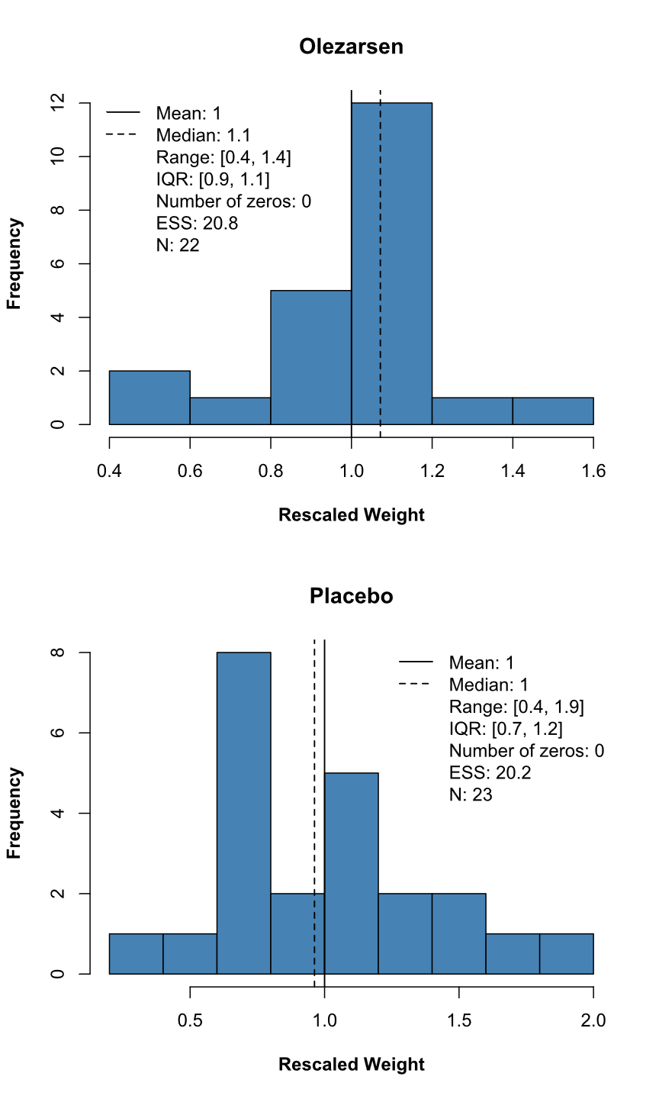
Abbreviations: AP – Acute Pancreatitis, ESS – Effective Sample Size, IQR – Interquartile Range, N – Sample size, TEAE – Treatment-Emergent Adverse Events, TRAE – Treatment-Related Adverse Events.
Figure B2: Histograms of patient weights for number of AP events analysis.
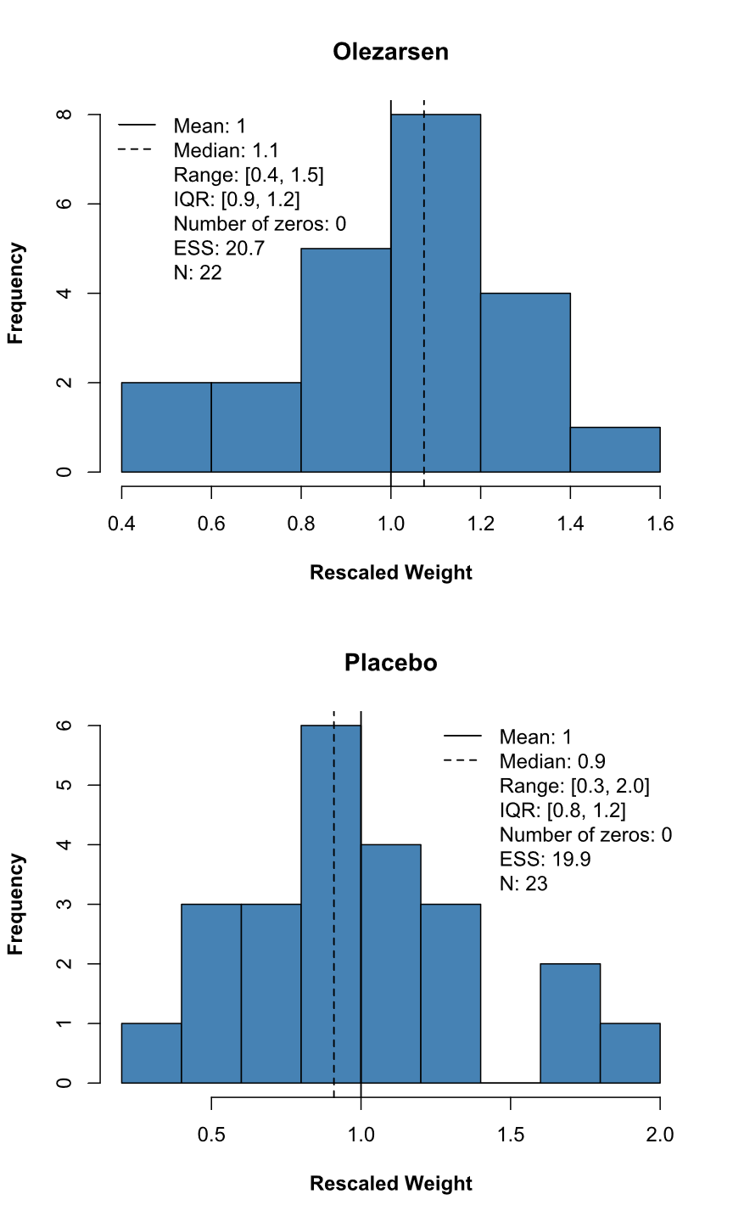
Abbreviations: AP – Acute Pancreatitis, ESS – Effective Sample Size, IQR – Interquartile Range, N – Sample size.

Figure B3: Histograms of patient weights for the fasting apoC-III and TG analyses.
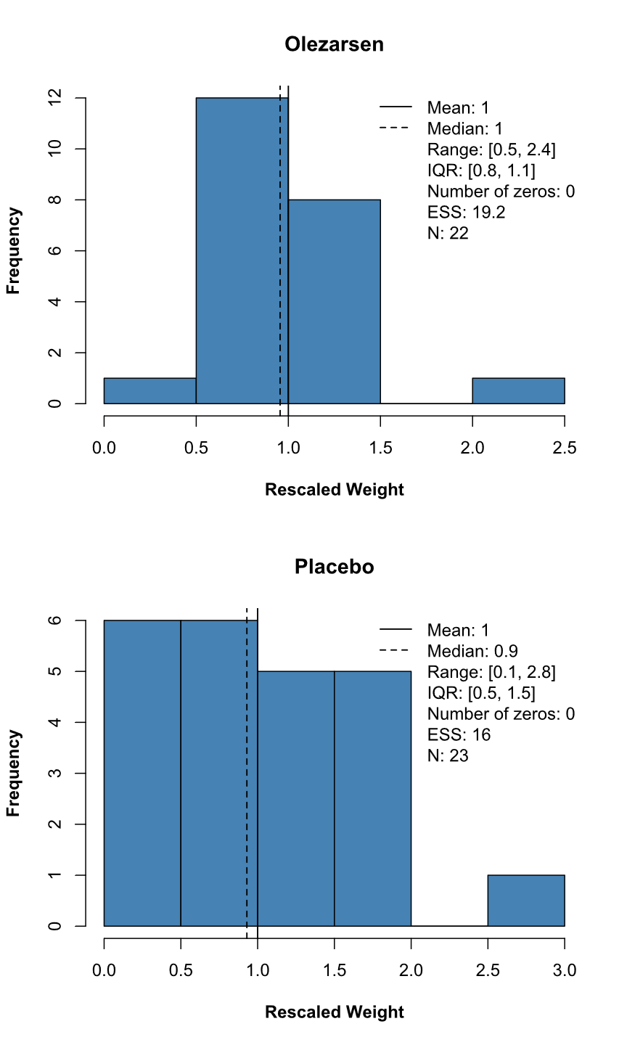
Abbreviations: apoC-III – Apolipoprotein C-III, ESS – Effective Sample Size, IQR – Interquartile Range, N – Sample size, TG - Triglycerides.

Figure B4: Histograms of patient weights for the SAE analysis.
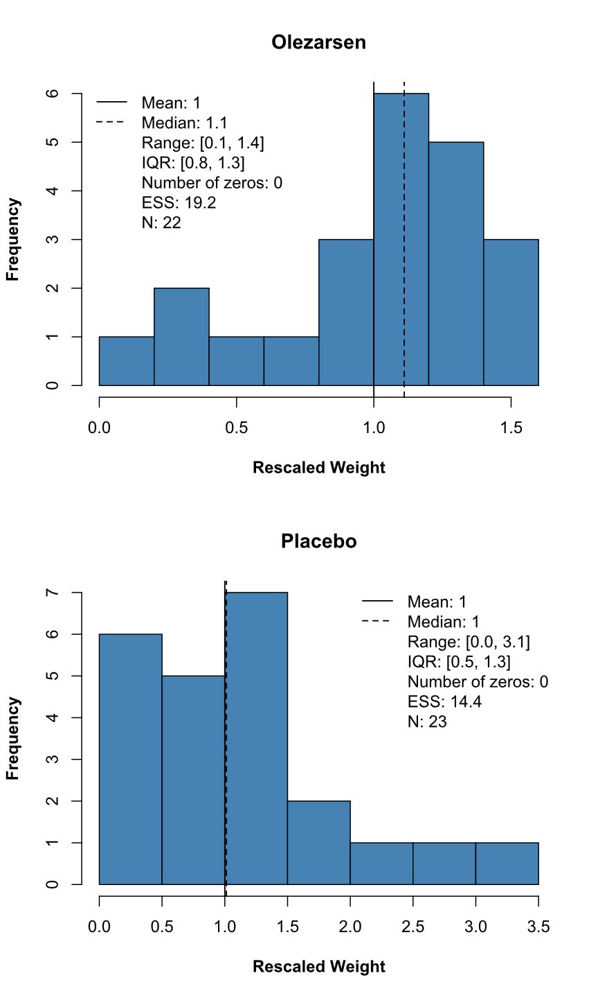
Abbreviations: ESS – Effective Sample Size, IQR – Interquartile Range, N – Sample size, SAE – Serious Adverse Event.

